A1:
V = float(input("Enter voltage (V): "))
R = float(input("Enter resistance (ohm): "))

if R <= 0:
print("Invalid resistance")
else:
I = V / R
print("Current =", I, "A")

if I > 2:
print("Fuse will blow")
else:
print("Circuit is safe")
RESULT:
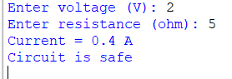

A2:
I = float(input("Enter current: "))

if I > 0:
print("Current flows from A to B")
elif I < 0:
print("Current flows from B to A")
else:
print("No current flows")
RESULT:
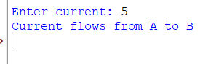

A3:
colour = input("Enter band colour: ").lower()

if colour == "black":
print("Digit = 0")
elif colour == "brown":
print("Digit = 1")
elif colour == "red":
print("Digit = 2")
elif colour == "orange":
print("Digit = 3")
elif colour == "yellow":
print("Digit = 4")
elif colour == "green":
print("Digit = 5")
elif colour == "blue":
print("Digit = 6")
elif colour == "violet":
print("Digit = 7")
elif colour == "grey":
print("Digit = 8")
elif colour == "white":
print("Digit = 9")
else:
print("Invalid colour")
RESULT:
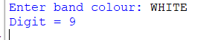

A4:
A = int(input("Enter A: "))
B = int(input("Enter B: "))

if (A != 0 and A != 1) or (B != 0 and B != 1):
print("Bits must be 0 or 1")
else:
print("AND =", A and B)
print("OR =", A or B)
print("XOR =", A ^ B)
RESULT:
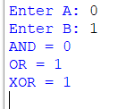

A5:
R1 = float(input("Enter R1: "))
R2 = float(input("Enter R2: "))
R3 = float(input("Enter R3: "))

if R1 <= R2 and R1 <= R3:
smallest = R1
elif R2 <= R1 and R2 <= R3:
smallest = R2
else:
smallest = R3

if R1 >= R2 and R1 >= R3:
largest = R1
elif R2 >= R1 and R2 >= R3:
largest = R2
else:
largest = R3

print("Smallest =", smallest, "ohm")
print("Largest =", largest, "ohm")
RESULT:
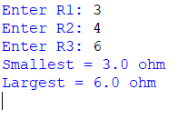

LOOPS:
B1:
R = 10

for V in range(1, 11):
I = V / R
print("V =", V, "V, I =", round(I, 1), "A")
RESULT:
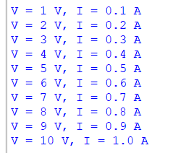

B2:
n = int(input("How many resistors? "))
total = 0

for i in range(1, n + 1):
R = float(input("Enter R" + str(i) + ": "))
total = total + R

print("Total resistance =", total, "ohm")
RESULT:
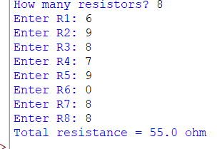

B3:
readings = [3.3, 3.1, 3.4, 2.9, 3.6, 3.0, 3.2]

count = 0
total = 0
highest = readings[0]
lowest = readings[0]

for V in readings:
if V > 3.2:
count = count + 1

if V > highest:
highest = V

if V < lowest:
lowest = V

total = total + V

average = total / len(readings)

print("Readings above 3.2 V:", count)
print("Highest:", highest, "V")
print("Lowest:", lowest, "V")
print("Average:", round(average, 2), "V")
RESULT:
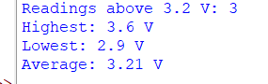

B4:
voltages = [12.6, 12.5, 12.5, 12.3, 12.1, 11.9,
12.0, 11.8, 11.6, 11.5, 11.5, 11.2]

current_length = 0
longest_length = 0
start_voltage = 0
end_voltage = 0
current_start = 0

for i in range(1, len(voltages)):
if voltages[i] < voltages[i - 1]:
if current_length == 0:
current_start = voltages[i - 1]

current_length = current_length + 1

if current_length > longest_length:
longest_length = current_length
start_voltage = current_start
end_voltage = voltages[i]
else:
current_length = 0

print("Longest continuous drop:", longest_length, "minutes")
print("Started at:", start_voltage, "V")
print("Ended at:", end_voltage, "V")
RESULT:
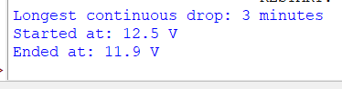

B5:
count_1 = 0
count_5 = 0
count_reject = 0

while True:
R = float(input("Enter resistance (0 to stop): "))

if R == 0:
break

if 99.0 <= R <= 101.0:
count_1 = count_1 + 1
elif 95.0 <= R <= 105.0:
count_5 = count_5 + 1
else:
count_reject = count_reject + 1

print("1% tolerance:", count_1)
print("5% tolerance:", count_5)
print("Reject:", count_reject)
RESULT:
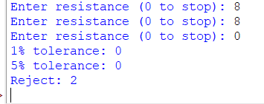

FUNCTIONS:
C1:
def ohms_current(v, r):
return v / r

def power_dissipated(i, r):
return i ** 2 * r

V = 12
R = 6

I = ohms_current(V, R)
P = power_dissipated(I, R)

print("Current =", round(I, 2), "A")
print("Power =", round(P, 2), "W")
RESULT:
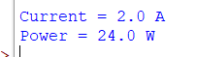

C2:
def parallel_resistance(resistors):
total = 0

for R in resistors:
total = total + 1 / R

return 1 / total

print("Equivalent resistance =", round(parallel_resistance([10, 10]), 2))
print("Equivalent resistance =", round(parallel_resistance([100, 200, 300]), 2))
RESULT:
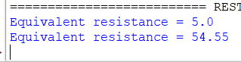

C3:
def decimal_to_binary(n):
binary = ""

while n > 0:
remainder = n % 2
binary = str(remainder) + binary
n = n // 2

return binary

print("Binary =", decimal_to_binary(10))
print("Binary =", decimal_to_binary(25))
RESULT:
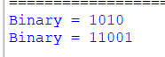

C4:
def loaded_divider(vs, r1, r2, rl):
unloaded = vs * r2 / (r1 + r2)

parallel = (r2 * rl) / (r2 + rl)

loaded = vs * parallel / (r1 + parallel)

return unloaded, loaded

result = loaded_divider(12, 1000, 1000, 500)

print("Unloaded voltage =", round(result[0], 2), "V")
print("Loaded voltage =", round(result[1], 2), "V")
RESULT:
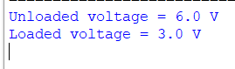

C5:
def star_to_delta(ra, rb, rc):
numerator = ra * rb + rb * rc + rc * ra

RA = numerator / rb
RB = numerator / rc
RC = numerator / ra

return round(RA, 2), round(RB, 2), round(RC, 2)

value = star_to_delta(10, 20, 30)

print("Delta resistance values =", value)
RESULT:
